Mario Pugh September 3, 2020

Explain in your own words why sending email from a server could be a useful capability for a systems administrator. How might this capability be abused for malicious intent? Name the type of attack this kind of automation would facilitate and define it.

System administrators write scripts for running processes, CPU utilization, memory utilization, zombie processes, load averages, Disk/SAN/NAS utilization, if incremental backups, full backups and disaster recovery drills were performed. Monitoring the IT infrastructure and issue alerts about potential problems.

In the event of an intrusion or issue, the sysadmin can check previous and real-time logs to diagnose and resolve the problem. Server health checkups, resource utilization, backup triggers, transfer files and logs.

Include in your submission a screenshot of your successful email terminal command and your recipient inbox showing the email arriving.

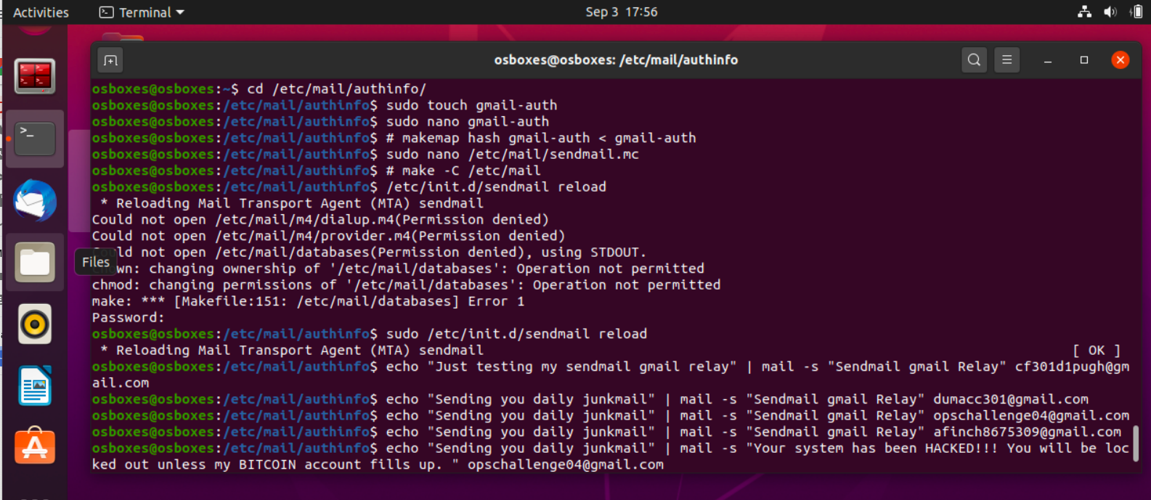

Received test file on my google account.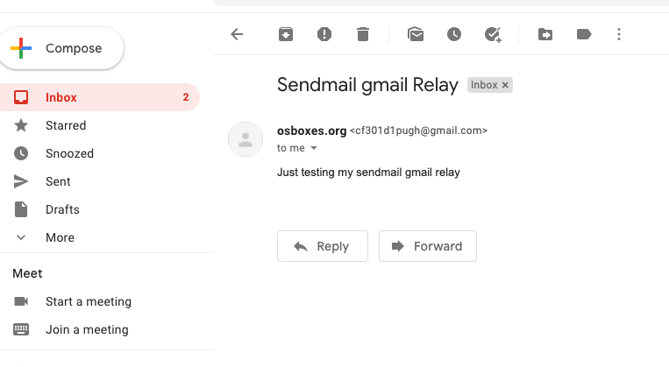

Tested with Courtney, she responded with “What happens if I write back?” I told her she had been hacked and requested Bitcoin.

